GIS Home

Spatial Data
GeoWeb
Hardware + Software
hardware
GPS
software
Teaching + Learning

Maps + Mapping
Social Science Data Services
US Census
Data Management & Publishing Guide
GIS Lab
Rotch Library, building 7-238
Contact Us
gishelp@mit.edu

Installing ArcGIS 10 on Windows XP at the Massaschusetts Institute of Technology
For instructions on installing ArcGIS 9.x visit: http://libraries.mit.edu/gis/software/arcgis_install92/
This document gives you step by step instructions for installing ArcGIS 10 (Arcinfo level) on your Windows Operating System machine. You should be patient during the loading process - it may take you an hour or more.
Warning: All site licenses at MIT are exclusively run on an MIT only basis to insure our adherence to the site licenses. Since your home computer is off of net 18, you can't run it without using a virtual private network. See this page to get one running on your home PCs: http://web.mit.edu/ist/services/network/vpn.html
If you have an earlier version of ArcGIS already installed, you must remove both ArcGIS Desktop and ArcInfo Workstation before starting the installation.
Install ArcGIS Desktop
ArcGIS 10 can be downloaded from MIT IS&T - mit authentication required.
Download "ArcGIS_Desktop10_122519.zip" and then extract all files (about 3.75 GB).
Once extracted, open the ArcGIS_Desktop10_122519 folder and run the "ESRI.exe< this see then should You file.>
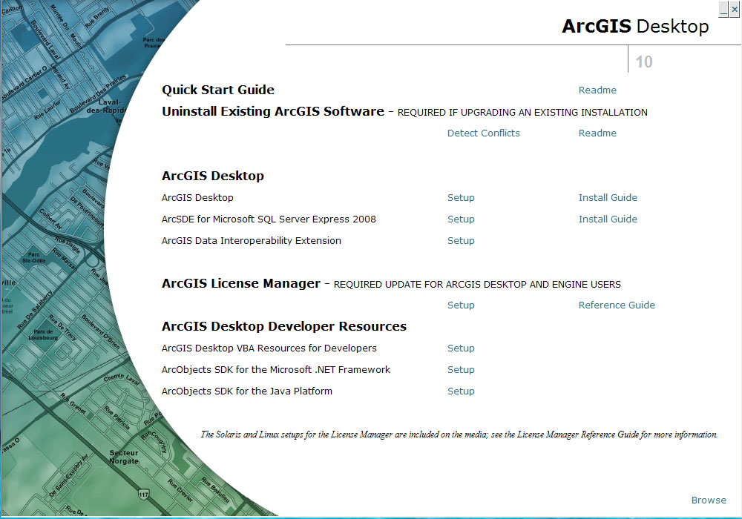
Click on "Setup" next to "ArcGIS Desktop." You will see this screen:
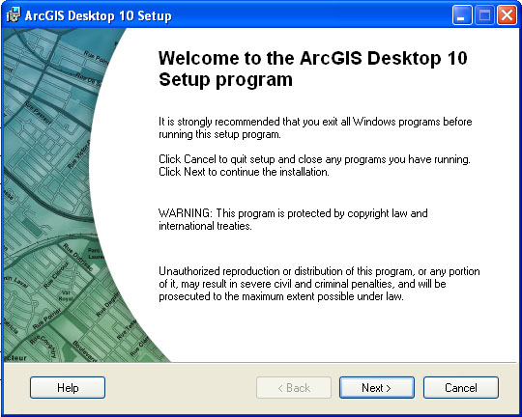
Click Next in this window.
A new window asks you to read the license file, which you should do. You should accept the license restrictions. You should also realize that this license entitles you to use ArcGIS for MIT purposes only.
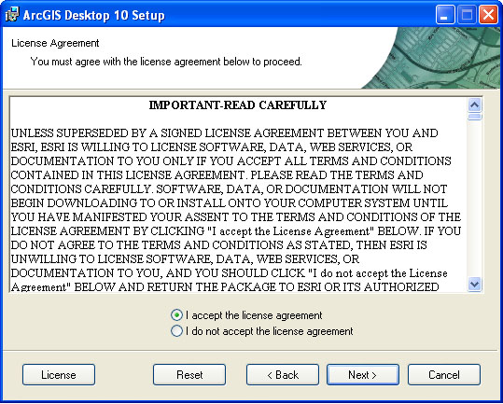
The Installation Type window opens next.
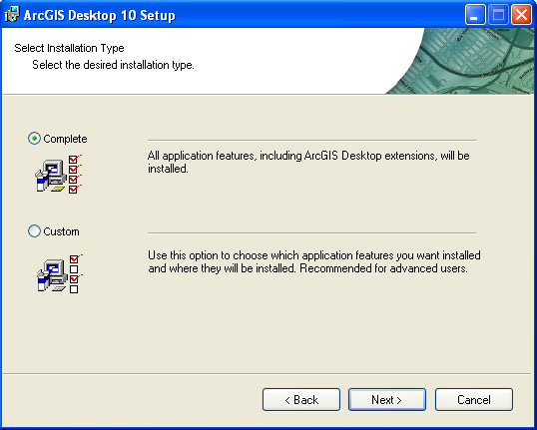
Choose the Complete installation then click on Next. The Destination Folder window opens next:
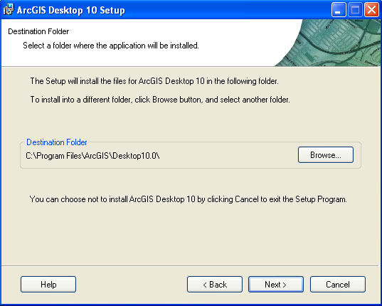
Under most circumstances (for almost all users), choose the default then click on next.
The Python Destination window opens next:
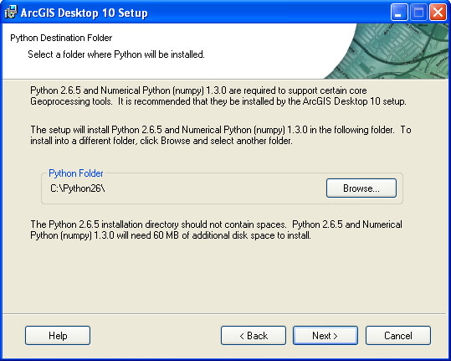
Again, most users will choose the default, then click on Next.
A confirmation window opens next:
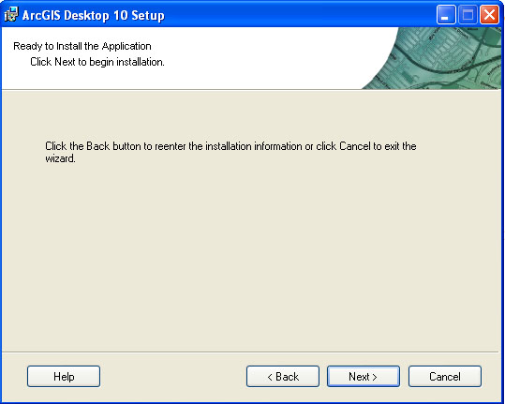
Click on Next. The install starts at this time. This can take several minutes. After the installation is complete, you should see the success window:
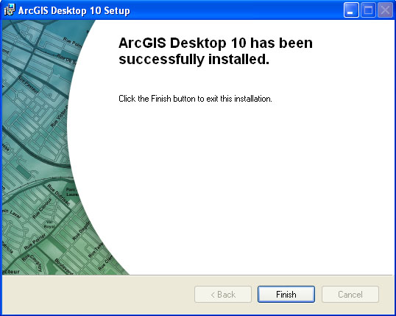
Click on Finish.
The ArcGIS Administrator Wizard window opens next:
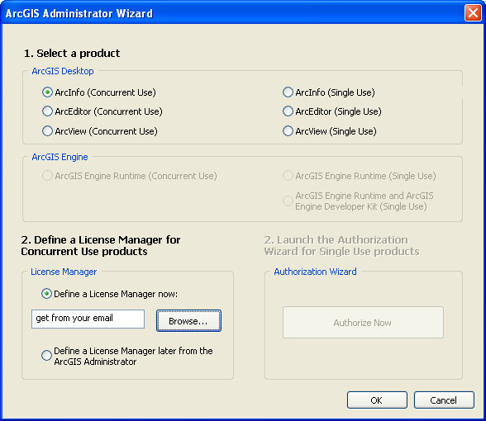
Under "1. Select a product," choose "ArcInfo (Concurrent Use)."
Under "2. Define a License Manager for Concurrent Use products," choose "Define a License Manager now."
Click OK.
You have successfully completed installing the Desktop software. The top install menu window reappears.
You have several choices here:
You should install the ArcGIS VBA Resources for Developers or SDKs only if you plan on programming in ArcGIS.
If you do not need the Resources for Developers, you can exit the Install Menu screen.
Installing ArcInfo Workstation
Go back to: https://downloads.mit.edu/vsls/esri/
Download "ArcInfo_Workstation10_121095.zip" and extract all files.
Once extracted, open the ArcInfo_Workstation10_121095 folder and run the Setup.exe file located in the Windows folder.
You will see the Arcinfo Welcome window:
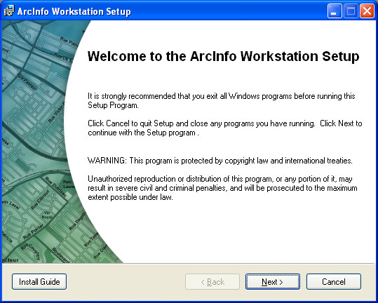
Click on Next. You will see the ArcInfo License Agreement window. Read the license then accept it then click on Next.
You will see the ArcInfo Installation Type window:
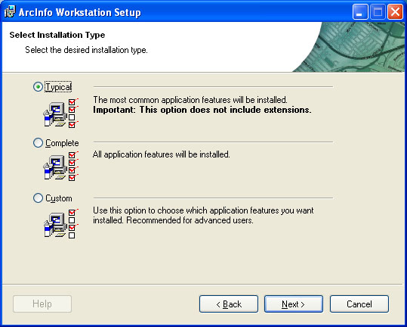
Click on Complete then on Next.
You will see the ArcInfo Workstation Destination Folder window. Most users will want to accept the default then click on Next.
You will see the Select Workspace folder window.
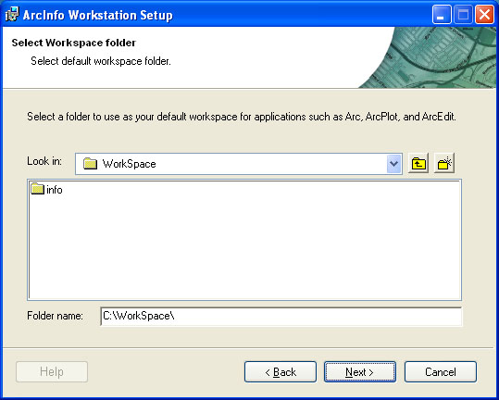
This is the folder that ArcInfo starts in, by default. For most users, you won't start ArcInfo (which is command line driven) but instead will rely on ArcInfo tools available through the ArcGIS Desktop interface. Most users will want to accept the default then click on Next
You will see the Start Installation window:
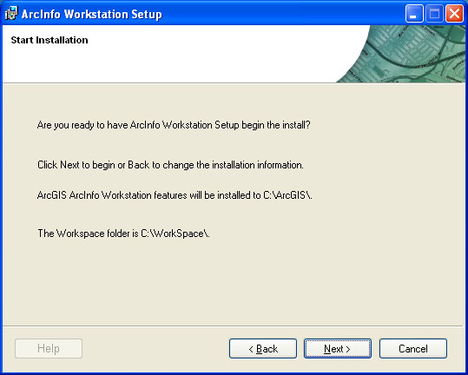
Click on Next. A Successfully Installed window will appear when the installation is complete. Click Finish
A Workstation Administrator window opens next.
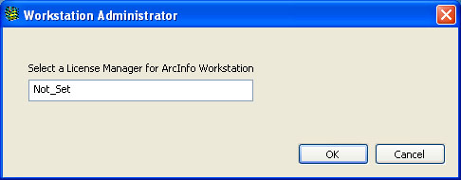
Replace "Not_Set" with the name of the License Manager listed at: https://downloads.mit.edu/vsls/esri/ Click OK
Setting the license manager
To set the license manager, use the Desktop Administrator. This is found from the Start Menu -> All Programs -> ArcGIS -> ArcGIS Administrator. You will see a window like this:
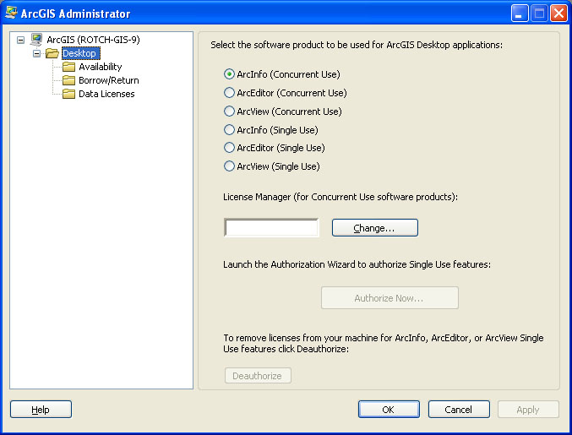
Click on the "Desktop" folder. Now click on the "Change" button on the right side of the window. You will find the name of the license server on the page where you downloaded the ArcGIS 10 Desktop software . Use this license server name to fill in the License Manager name. Click on OK to confirm the name then click on OK in the ArcGIS Administrator window.
Check for updates at the ESRI Support Center. Download and install the most recent Service Pack.
The easiest way to start working with a GIS project is by bringing in data from the MIT Geodata Repository. The MIT Geodata Search Tool runs on top of ESRI's ArcGIS. To download and install, and set up a user account for the MIT Geodata Search tool visit: http://libraries.mit.edu/gis/data/repository/install_geodata_census.html.
You are now ready to run ArcGIS on your PC. Be sure to restart your computer.

