Final Report: Spectral Measurements of the Bio-Spectrum Healthcare Device

Summary

Measurements of the emission spectra of the Bio-Spectrum Healthcare Device were
performed over a range extending from the visible through the microwave spectral domains. In terms of wavelengths, the spectra were measured from 400 nm to one cm. A comparison was made with emission spectra from thermal sources, including a 1300 degree Kelvin heat lamp. The results demonstrate that the Bio-Spectrum Healthcare Device is primarily a blackbody emitter with an emitter temperature of approximately 650 degrees Kelvin. This may be compared with the results of a thermocouple measurement of the temperature of the emission element. The thermocouple result was approximately 500 degrees Kelvin with a potential error of plus or minus 200 degrees Kelvin due to the fact that permanent contact could not be established with the emission element without damaging the element. Minor deviations from the standard blackbody emission spectrum were noted and correspond to emissions expected of a mixture of rare-earth elements. The deviations are a small percentage of the total emission and are of low intensity relative to the intensities of the heat lamp in the same spectral domains. Spectral characteristics initially indicating deviation from the blackbody characteristics were observed, but these anomalies were found to be removed by a thorough examination of the reference spectra provided by the heat lamp. Our conclusion is that the Bio-Spectrum Healthcare Device is essentially a thermal emitter of low intensity relative to a heat lamp.

Measurement Methods

Measurements in the visible portion of the electromagnetic spectrum were carried out with a sensitive spectrophotometer and photomultiplier tube. Emissions were observed to be small relative to the heat lamp source between 400 nm and 700 nm wavelength, (The emission is not easily perceived by the eye in a darkened room). The data were entered into the total spectrum analysis solely in order to provide comparison with the blackbody curve and are inconsequential otherwise.
Measurements from 700 nm to 80 microns wavelength were carried out with a Beckman infrared spectrometer. In this spectral region the emissions were significant and the intensity was comparable to that of the heat lamp.
Measurements from 40 microns to 1000 microns were carried out with a highly sensitive infrared through submillimeter wave Bruker IFS 66V Fourier Transform Interferometer using a bolometer detector cooled to 4 degrees Kelvin by a bath of liquid helium. A number of comparison sources were used as discussed in the Results. The Bio-Spectrum Healthcare Device produced an emission intensity lower than that of any of the comparison sources and above background levels only to the extent expected of a blackbody emitter. All data were verified by an independent lab (U. of Mass., Lowell)
Measurements from 500 microns to one cm wavelength were carried out with a microwave spectrometer and no significant emissions were found relative to background with the exception of a peak centered at 8.1 mm wavelength. However, this peak was comparable to intensities at smaller wavelengths and is attributable to the fact that it is preceded by an absorption notch due to water vapor. All of the structure observed was analyzed by including the effects of absorption cross sections of diatomic and triatomic molecules present in the atmosphere. Measurements were attempted extending to three cm, but the emissions in this range were not above normal background levels in an open environment.
All spectral measurements were carried out in a controlled environment with appropriate shielding from electromagnetic noise. Shielding was provided by a grounded metal enclosure. Interior reflections and other extraneous radiation were characterized in a background survey over each spectral range.

Data

Figure 1 shows the calculated blackbody emission curve of an ideal source at a temperature of 1300 degrees Kelvin. Spectral data on the reference heat lamp match this curve to within experimental error.

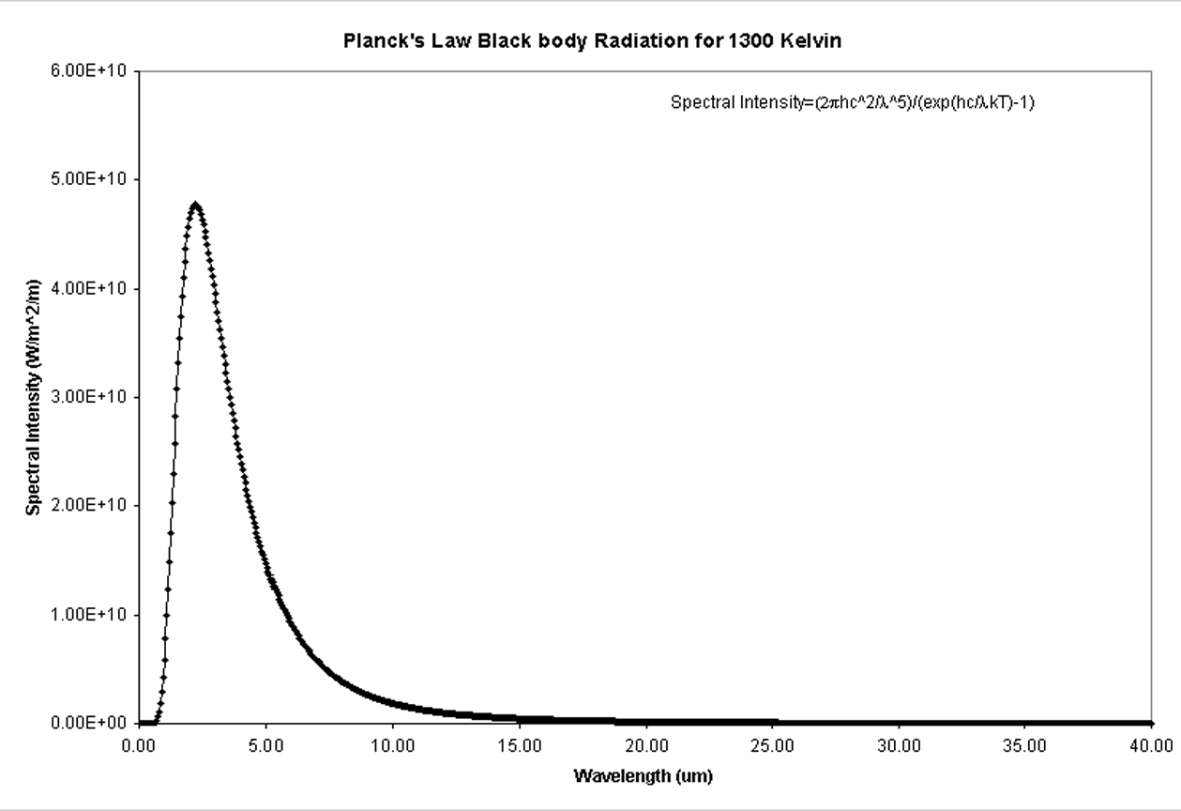
Figure 1. Blackbody Energy Density Emission Versus Wavelength for Wavelengths Between 0.4 micron and 40 microns for an Emitter at a Temperature of 1300 degrees Kelvin. This spectrum corresponds to the reference heat lamp used in the Beckman infrared spectrometer.

The blackbody temperatures are given in degrees Kelvin. To convert to degrees Celsius one can subtract 273 (approximate). That is, 273 degrees Kelvin is zero degrees Celsius and the boiling point of water is 373 degrees Kelvin, or 100 degrees Celsius.

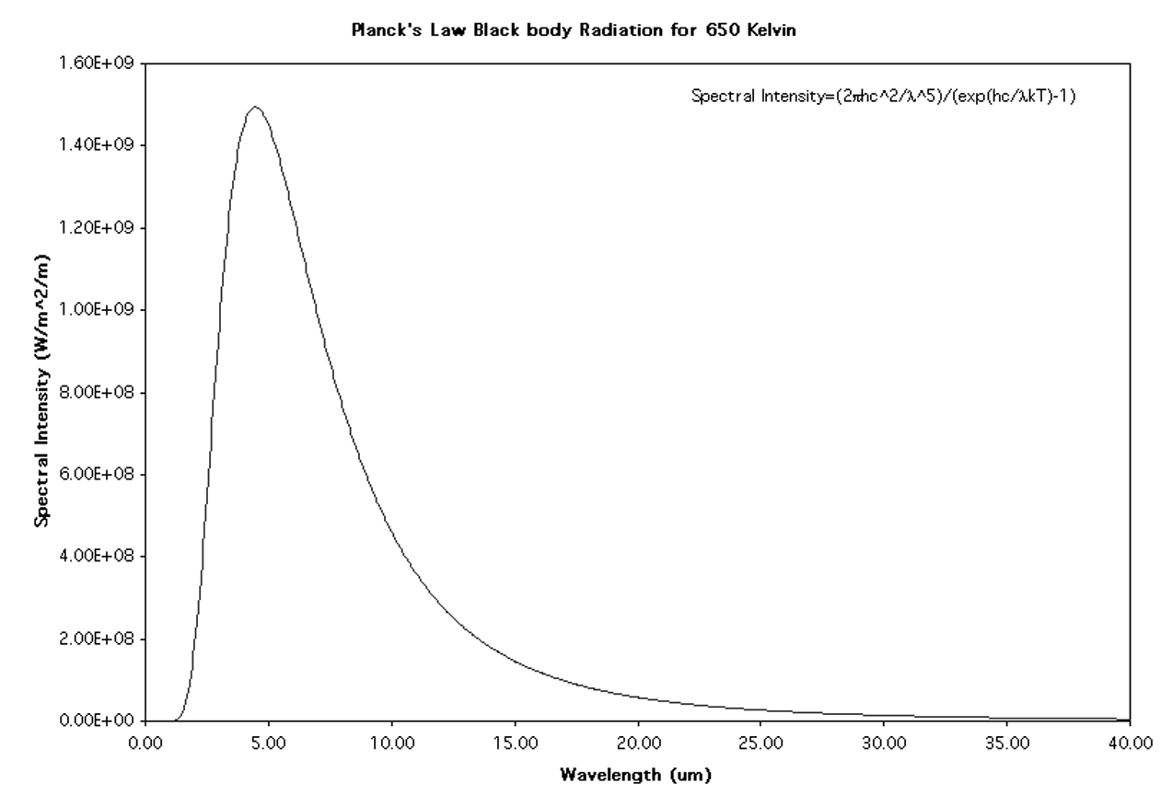
Figure 2. Blackbody Energy Density Emission Versus Wavelength for Wavelengths Between 0.4 micron and 40 microns for an Emitter at a Temperature of 650 degrees Kelvin. The emission peak is at a longer wavelength than is found for the reference heat lamp due to the lower temperature chosen for this curve.

Figure 3. The light, discrete, data points in this graph are the raw data produced by the Bio-Spectrum Healthcare Device in the Beckman infrared spectrometer. This data is not the actual spectrum because the intensity must be referenced to that of the heat lamp. The intensity must be divided by the intensity produced by the reference. The data for a 650 degree Kelvin blackbody emitter when multiplied by the normalized heat lamp intensity for comparison purposes produces the dark curve. There is a potentially misleading peak in the yellow curve that would appear to produce a much higher emission if extrapolated from 15 microns, but the curve levels off just as does the blackbody curve. An absorption band due to carbon dioxide lies at 15 microns. The fact that there is a peak can be accounted for by the presence of compounds coated onto the emitter. The presence of rare-earth oxides is highly probable and pyroxene may also be present. (See below)
Figure 4. Referenced Spectrum of the Bio-Spectrum Healthcare Device (discrete points) in comparison with the blackbody curve of Figure 2 for a 650 degree Kelvin thermal source. While the temperature of the Bio-Spectrum Healthcare Device could not be determined with high accuracy by thermocouple measurements, the match between the data and the expected blackbody emission spectrum is sufficiently close to predict that the temperature is likely to be approximately 650 degrees. The total emission is weak relative to that of the heat lamp, but is comparable in order of magnitude. This represents an energy density well within human tolerance at distances of a few centimeters. The data were further extended to 80 microns with difficulty due to the low intensities beyond 40 microns. The blackbody curve was well-tracked by the Bio-Spectrum Healthcare Device in this regime.

The numerical data for the above curves is available as a Microsoft Excel spreadsheet. This is attached to the present report on a zip disk.

Far Infrared Through Millimeter Spectra
The spectrum from 40 microns (0.04 millimeters) to the microwave regime at the upper end of the sub-millimeter wave scale was very difficult to obtain due to the extremely low intensities involved. A liquid-helium-cooled detector was used. Three reference sources were used as shown in Figure 5.

Figure 5. Raw Data for the Infrared through 500 microns (Sub-mm) region. Data here are displayed with the lowest wavelengths on the right in contrast to the previous figures due to the manner in which the data were recorded. Common structure features are not due to the source, but are atmospheric absorption properties. At each point one can see the relative strengths of the various sources. The Bio-Spectrum Healthcare Device emission intensity is just above the background level and has the least intensity of all the sources.

Measurement Technique

Spectroscopic data were acquired on a Bruker IFS 66V Fourier Transform Infrared Interferometer configured with an internal Hg-arc lamp and silicon carbide globar. The commercial blackbody source was an Infrared Industries model #463 IR source with a maximum temperature of ≈ 1300 K. The energy from the IR source and the health source were directed into the interferometer through the emissions port (see Figure 6). The energy from the arc lamp and globar was directed into the interferometer with a simple change in optics. The measurement system was configured with a 6-µm-thick mylar beamsplitter and a liquid-helium-cooled detector (NEP ≈10⁻¹³ ). An optical filter (at 4.2 K) designed to block wavelengths shorter than ≈ 15 µm from reaching the detector was also used.

Figure 6. Bruker interferometer showing locations of the Hg-arc lamp, SiC globar, and emissions port where the IR source and health source were placed for their respective measurements.

FT-IR Data and Analysis

In order to acquire accurate spectra of the blackbody sources, all vacuum windows on the interferometer were removed and hence, measurements were acquired at atmospheric pressure. Because the measurements were collected at atmospheric pressure, data contain several sharp features which can be attributed to atmospheric water vapor and CO₂ absorption.
A summary of all the data acquired is shown in Figure 5 and redisplayed in Figure 7. For convenience, the data are expressed as a function of wavelength in microns. It is important to note that the spectra in this report do not appear as classic blackbody radiation curves because they are influenced by the thermal emission from the detector window, the self-emission from the interferometer (primarily from the KBr beamsplitter), and the fact that data were acquired at wavelengths longer than where peak spectral output occurred.

Figure 7 Spectral behavior of the health source and several laboratory blackbodies.

By ratioing the various single beam spectra of Figure 7, information about the spectral behavior of the health source can be ascertained. In the following figures, the spectral response of the health source is compared to other various blackbody sources. Again, the “noise” in the following spectra is due to the influence of atmospheric water vapor and CO₂.

Health source behavior at “high” and “low” settings

The spectral response of the health source was acquired at both high and low settings and the ratio of these responses is given in Figure 3. The source was not moved between measurements and was given at least one hour to reach thermal equilibrium. The source’s output at the “low” setting was 50%-60% of its output at the “high” setting at mid-infrared wavelengths and 60%-80% at far-infrared wavelengths. In all subsequent data plots, the source’s output was set to “high”.

Figure 8 Ratio of health source output at low and high settings.

Health source behavior relative to apparatus/room emission

The output of the health source was compared to the blackbody radiation emitted by the room and interferometer itself. The self-emission of the Fourier-transform interferometer was easily observed with the liquid-helium-cooled detector even though a cold filter was used to suppress as much of the room temperature blackbody emissions as possible. The plot in Figure 4 shows the ratio of the health source’s output to the blackbody radiation emitted by the room and interferometer. The peak in the data near
25 µm is due to the low signal-to-noise ratio of the data and not due to any particular behavior of the health source. It is interesting to note that at longer wavelengths, the data approaches a constant value of ≈ 2.5. Using the Rayleigh-Jeans law and assuming that emissivities are unity implies a lamp temperature of ≈ 725 K (290 K x 2.5) which is close to the assumed temperature of 650 K.¹

Figure 9 Health source output compared to apparatus/room emissions.

Health source behavior relative to a 1300 K blackbody source

The spectral behavior of the health source was compared to a ≈ 1300 K blackbody source (Infrared Industries model #463). Radiation from both sources were collected through the interferometer’s emissions port by locating the source near the port’s collection mirror and positioning the source for maximum signal. Given the limited scope of the effort, special collection mirrors or lenses were not used. Both mid and far-infrared data sets were acquired and are shown in Figure 10.

Figure 10 Health source output compared to a ≈ 1300 K blackbody.

Two features should be noted about the data in Figure 10. First, at wavelengths longer than ≈ 200 µm, the ratio is relatively flat indicating that the health source does not behave differently than the 1300 K source aside from its temperature. Secondly, the ratio is observed to increase slightly between 20 µm and 80 µm. Increasing output at wavelengths longer than 20 µm was also observed by Ferrell² where the ratio of health source output to a 1300 K source (Figure 11), shows an increasing ratio between 5 µm and 40 µm.

Health source behavior relative to a Globar

Spectral behavior of the health source was also compared to a water-cooled silicon carbide globar. The globar is a standard IR source used for mid-infrared Fourier transform spectroscopy and has a temperature of approximately 1500 K.³ The spectral behavior of the health source relative to the globar (Figure 7) has features similar to those in Figure 10. The ratio increases with wavelength until ≈ 100 µm where it slowly begins to decrease until it levels out at ≈ 0.4. Again, determination of the source’s temperature from the data is difficult because the ratio depends not only on the respective temperatures, but also on how well the radiation was coupled into the interferometer. However, it is interesting to note that the Rayleigh-Jeans law predicts a health source temperature of ≈ 600 K (0.4 x 1500 K) which is very close to the previously stated value of 650 K.

Figure 11 Health source output compared to a ≈1500 K SiC globar.

Health source behavior relative to a Hg-arc lamp

The spectral behavior of the health source was also compared to the output of a Hg-arc lamp. This type of lamp is commonly used as a source of incoherent far-infrared radiation in Fourier transform spectroscopy. The literature⁴ indicates that its temperature is similar to the globar’s, but the arc lamp’s advantage is due to its higher emissivity compared to silicon carbide for wavelengths longer than ≈ 100 µm. This behavior was easily observed by comparing the globar output relative to the arc lamp (Figure 12). The relative behavior is best displayed as a function of frequency and is therefore plotted versus wavenumber (cm⁻¹). At the higher frequencies, where the emissivities of both silicon carbide and the quartz envelope of the arc lamp are close to unity, the ratio of the outputs implies an arc lamp temperature of ≈ 1500K. However, for frequencies lower than 125 cm⁻¹ the emissivity of silicon carbide begins to fall off which explains why the ratio steadily climbs in the far-infrared region.

Figure 12. Ratio of Hg-arc lamp output relative to the SiC globar. The rise below 125 cm⁻¹ is due to the globar’s decreasing emissivity in the far-infrared region.

The ratio of the health source output to the Hg-arc lamp output is shown in Figure 13. The ratio steadily decreases with wavelength making it difficult to estimate the health source’s temperature by comparison to the arc-lamps (≈1500 K). As observed in the data of the previous figures, the lamp’s output increases slightly between 20 µm and 60 µm. This behavior is not fully understood, but is most likely due to minor changes in the health source’s emissivity at these wavelengths.

Figure 13. Health source output compared to a Hg-arc lamp. The gradual decrease above 100 µm is most likely due to the gradual decline of the health source’s emissivity in the far-infrared.

Conclusion

The mid and far-infrared through 1 cm wavelength spectral behavior of a ≈ 650 K health source was measured using a Fourier Transform Interferometer and a liquid-helium-cooled bolometer detector. In addition to acquiring spectra on the health source, data were acquired on a silicon carbide globar, a Hg-arc lamp, a 1300 K blackbody source, and the thermal emission from the room and interferometer itself. Data on the health source were ratioed to the response of the various blackbody sources. A survey of all the data indicate that the health source does not exhibit any unusual blackbody behavior compared to the other sources studied.

Were a source of microwaves (3 cm down to 0.5 mm, for example) present, there would likely be a sufficiently large bandwidth to produce a higher emission at lower wavelengths. But microwaves between 0.5 mm and 3 cm generally are produced by a klystron or magnetron. It is possible to produce microwaves by applying high-voltage pulses that cause diode breakdown, but these sources are typically 2 cm or longer wavelength and produce very short pulses. There does exist a Russian backward-wave oscillator that produces emission at 220-315 GHz. However, this would be seen in the data above if it were part of the Bio-Spectrum Healthcare Device.

Analysis

The intensity of the Bio-Spectrum Healthcare Device is relatively weak compared with all sources examined. Additional data not shown above and extending to 3 cm wavelength provided no significant intensities. The biological effectiveness of the Bio-Spectrum Healthcare Device cannot be determined by the spectral data, and it appears unlikely to be more effective than a heat lamp unless there are emissions from the heat lamp which reduce the effectiveness of the treatment and/or unless the small peak near 15 microns (near a relatively strong carbon dioxide absorption peak) is significant. This peak corresponds to a dip in the reflectance of compounds such as pyroxene.
Figure 14 shows atmospheric transmission in this region together with data on a thermal source and room-temperature blackbody emissions.
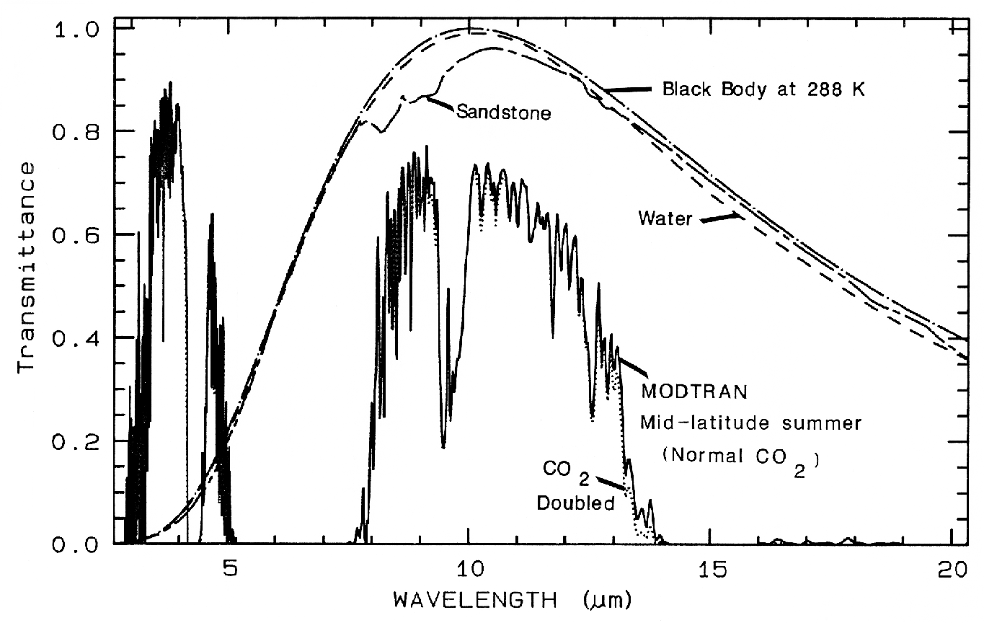
Figure 14. Atmospheric Transmission Versus Wavelength in Microns. (Clark). The carbon dioxide absorption is seen commencing just below 15 microns.

We note that most atmospheric absorption is due to water vapor for the mid infrared. Below is the reflectance spectrum for four rare earth oxides. A dip in the reflectance corresponds to an absorption and occurs at the same wavelengths as emissions in general for all materials.

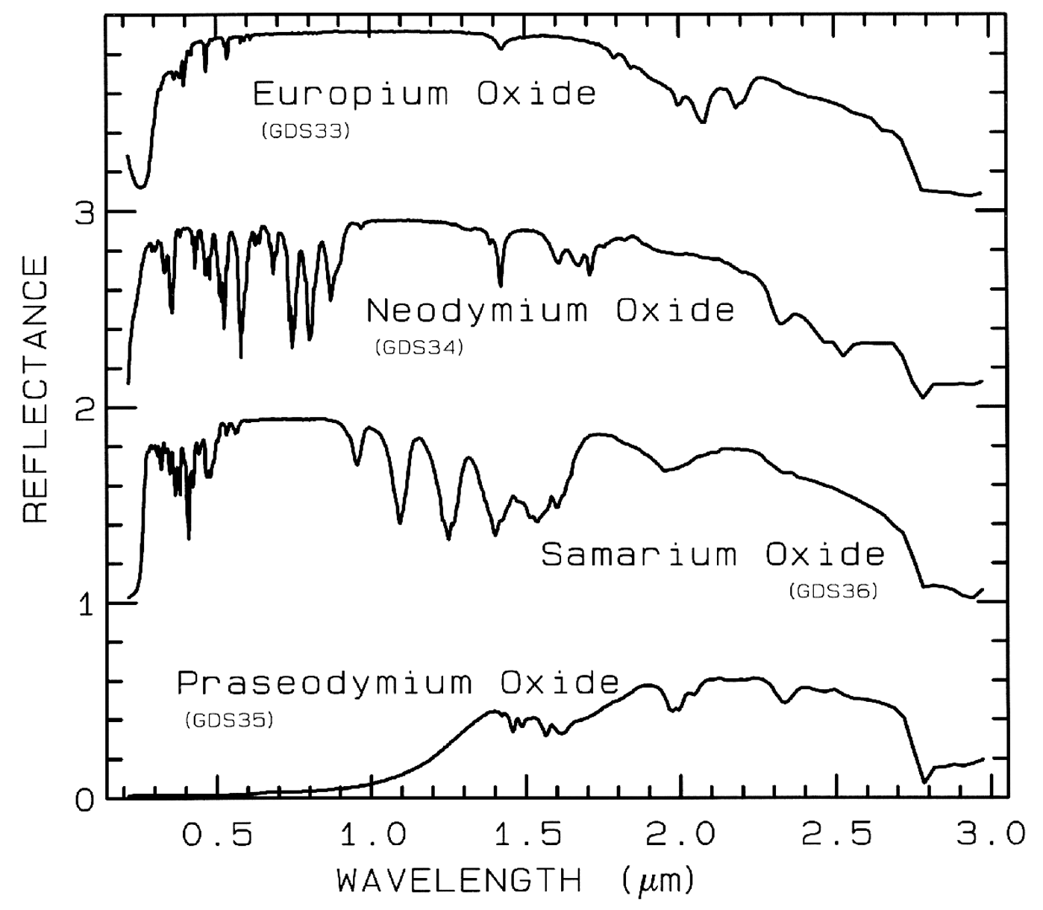
Figure 15. Reflectance of Rare-Earth Oxides in the Near Infrared region. There is structure for these compounds also present in the visible (some fish are colored due to the presence of these compounds). (Clark)

The structure in the near infrared is a very likely contributing agent in the structure of the emissions from the Bio-Spectrum Healthcare Device in the infrared.
The reflectance for pyroxene is shown in Figure 16. It varies with grain size
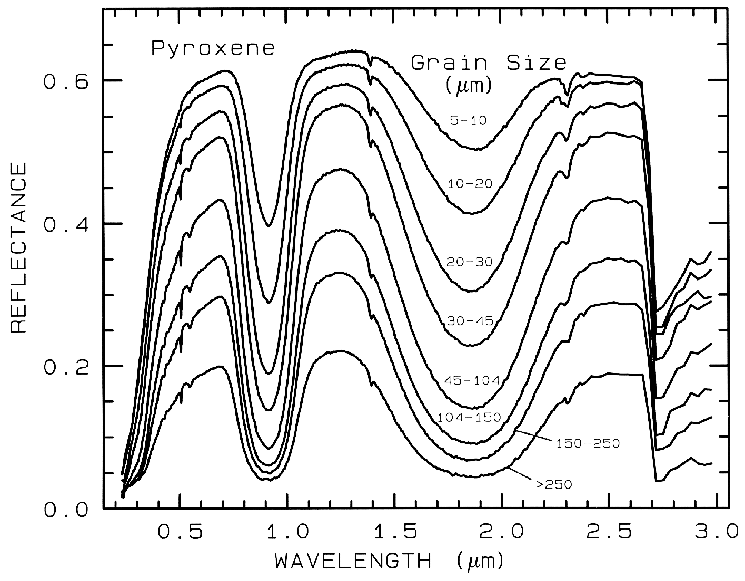
Figure 16. Near Infrared Reflectance of Pyroxene as a Function of Wavelength for Various Grain Sizes. (Clark)
As with a variety of minerals, pyroxene can contribute structure to the infrared spectrum of an emission source. The intensity is a strong function of grain size, but the spectrum characteristics are otherwise little changed. The effect of grain size is quite different in the mid infrared in terms of the effect on intensities, but again the spectral characteristics are otherwise not affected. Pyroxene is chosen here because it not only contributes structure in the near infrared, but it also has a reflectance dip near 15 microns—a necessary spectral characteristic for producing the spectral character of the Bio-Spectrum Healthcare Device. However, no chemical analysis was performed so that the presence of any particular compounds on the emission element is speculative. Data are shown here simply to indicate that the emitter is coated with some mixture of compounds. Whether or not this is significant is not known. The mid infrared spectrum is shown in Figure 17 below.
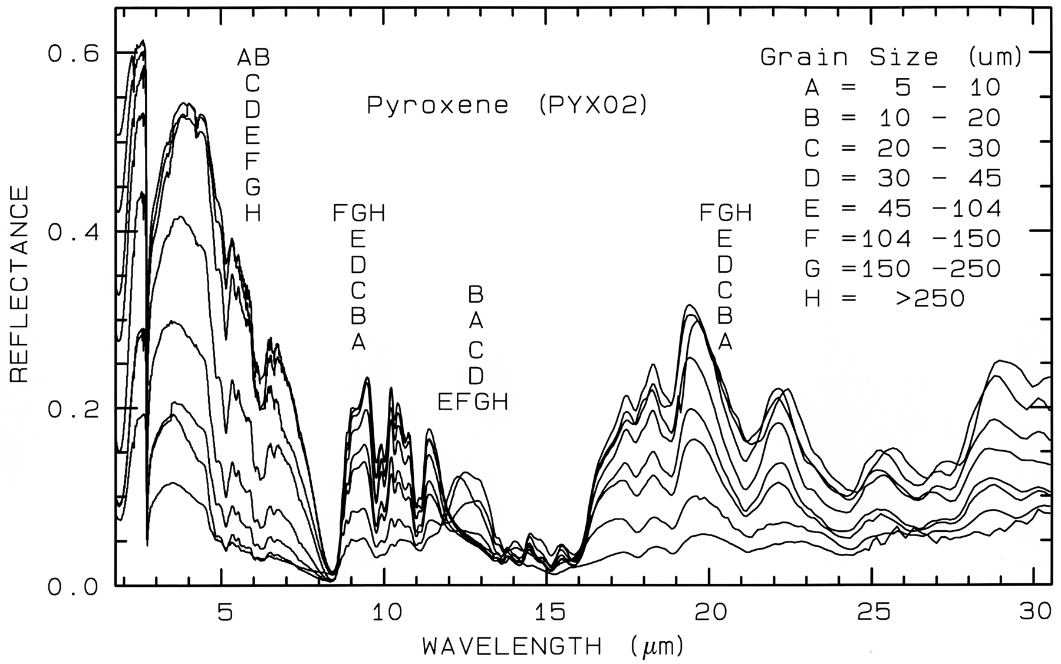
Figure 17. Mid Infrared Reflectance of Pyroxene as a Function of Wavelength for Various Grain Sizes. There are reflectance dips at 8.2 microns and at 15 microns indicating that emissions at these wavelengths have peaks when it emits electromagnetic radiation. These peaks can overcome the effects of atmospheric absorption by small molecules if the emission is of sufficient intensity. (Clark)

Conclusions
Spectral data obtained for the Bio-Spectrum Healthcare Device have been obtained across a broad spectral range, the data showing the device to emit at relatively low intensity. Spectral structure is present due to coating with unspecified compounds. The significance of the structure is not known, but any biological effects are very likely not due to the presence of particular spectral emissions, as these are very weak. It is possible that the presence of a weak source with certain spectral characteristics missing may be of significance, but this appears to be the sole possibility.

References

Chandrasekhar, S., 1960, Radiative Transfer, Dover Publ. Inc., New York, NY, 393p.

Clark, R.N., 1995, Reflectance Spectra, AGU Handbook of Physical Constants 12 pages.

Farmer, V.C., 1974, The Infra-Red Spectra of Minerals, (V.C. Farmer, ed.) Mineralogical Society, London, 539pp.

Hapke, B., 1993, Introduction to the Theory of reflectance and Emittance Spectroscopy, Cambridge University
Press, New York.

Mustard, J. F., and C. M. Pieters, 1989, Photometeric phase functions of common geologic minerals and
applications to quantitative analysis of mineral mixture reflectance spectra, J. Geophys. Res. 94,
13,619-13634.

Nicodemus, F.E., 1965, Directional reflectance and emissivity of an opaque surface. Applied Optics, 4,
767-773.

Sunshine, J.M. and C.M. Pieters, 1991, Identification of modal abundances in spectra of natural and laboratory
pyroxene mixtures: a key component for remote analysis of lunar basalts (abstract), in Lunar and Planetary
Science XXII, 1361-1362, Lunar and Planetary Instute, Houston.

